Power Supply Block
ECE44x Wearable Sensor for The Blind Group 34

Keywords—Power supply;3.3 Volt;5 Volt; block description; design verification

Introduction
The purpose of this document is to describe how the Power Supply being used on the project, to ensure that the power supply can be used without any further testing and work as intended. The power supply two part, the first part will create the 3.3 V DC and the second part 5 V DC. This document will be used to overview of all the function, properties, schematic, and verification of the design, so that the future use of the power supply can be simplify.

Block Overview
The power supply, is a module that convert the voltage input in which 6 Volt, into a different voltage output. the usr_cntrls_pwr_spply_usrin will receive the voltage input, then the step-down power supply will reduce to 3.3v and 5 volt, in which 3.3 volt will be used to pwr_spply_lsr_tf_snsr_dcpwr, pwr_spply_mgntmtr_dcpwr, pwr_spply_hptc_fdbck_dcpwr, and 5 volt will be on pwr_spply_mcrcntrllr_dcpwr, pwr_spply_bltth_dcpwr, pwr_spply_ultrsnc_snsr_dcpwr. The block diagram of the module system can be seen on on figure 1.

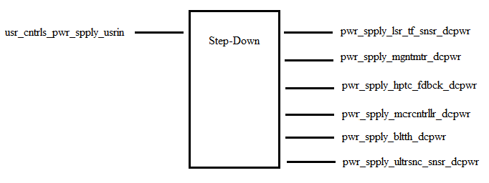
- Black Box Diagram of Power Supply Block
- Display Block Interfaces and Properties
Interface | Properties
usr_cntrls_pwr_spply_usrin | 1.Power switch: On Off
pwr_spply_lsr_tf_snsr_dcpwr | 1.Min Voltage: 2.6V  2.Max Voltage: 3.5V  3.Nominal Current: 20µA (between measurements)  4. Peak Current: 20mA (during measurement)
pwr_spply_mgntmtr_dcpwr | 1.Min Voltage: 1.95V  2.Max Voltage: 3.6V  3.Nominal Current: 5µA (standby)  4. Peak Current: 0.5mA (measurement)
pwr_spply_hptc_fdbck_dcpwr | 1.Inominal: 50mA +/- 10% at 100% duty cycle  2.Ipeak: 60mA  3.Vmax: 3.6V  4.Vnominal: 3.3v +/- 10% at 100% duty cycle
pwr_spply_mcrcntrllr_dcpwr | 1.Min Voltage: 1.8V  2.Max Voltage: 5.5V  3.Nominal Current: 9mA  4.Peak Current: 20mA
pwr_spply_bltth_dcpwr | 1.Min Voltage: 3.6V  2.Max Voltage: 6V  3.Nominal Current: 30mA +-10% (During pairing)  4. Nominal Current: 8mA +- 10% (After pairing)
pwr_spply_ultrsnc_snsr_dcpwr | 1.Min Voltage: 3 V  2.Max Voltage: 5.5 V  3.Nominal Current: 5mA  4.Peak Current: 30mA

Verification
Based on the interfaces for this block, a verification (testing) process needs to be indicated. This will allow for the final constructed design to be tested verifying that all of the interface properties have been met and that the block is ready for integration into the system

Power Input Testing
Link to Video

Power Output 3.3Volt Testing
Link to Video

Power Output 5Volt Testing
Link to Video
The block will be categorized as pass, when all the testing was pass.

Design
The Wiring Diagram (Fig. 2) presents the block design, including the interfaces of the block. These interfaces are further elaborated through validation information given in Table 2, which demonstrates externally-supported validation for each of the block’s properties. While the Pulse diagram (Fig.3), is to demonstrate how the ultrasonic module pulse works.

Wiring Diagram
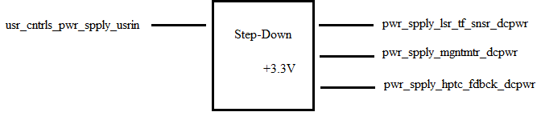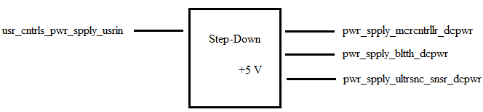
- Wiring Diagram for the Power Supply Block

Design Validation
For this block, the Power Supply that being chooses is " ". That sensor was chosen because " ". The table below (Tabel2), will validate the needed of each block
.

- Interface Property Validation for the ultrasonic sensor Block
Property | Validation

- bill of materials

REFERENCES

